https://mygainwell-my.sharepoint.com.mcas.ms/:p:/g/personal/brittaney_thompson_gainwelltechnologies_com/ERr2UzISez9HkHderUnQiHgBxN0uQurZeEy8AJFSVQcqxg?e=FOgR5o

Slide 5:

Two different Pharmacy Reference Guides

Fee for Service located here: [Gainwell OHSPBM FFS Pharmacy Reference Guide v1.0_07.2023.pdf (ohio.gov)](https://spbm.medicaid.ohio.gov/SPDocumentLibrary/DocumentLibrary/User%20Guides/Gainwell%20OHSPBM%20FFS%20Pharmacy%20Reference%20Guide%20v1.0_07.2023.pdf)

Managed care located here: [SPBM Pharmacy Reference Guide.pdf (ohio.gov)](https://spbm.medicaid.ohio.gov/SPDocumentLibrary/DocumentLibrary/User%20Guides/SPBM%20Pharmacy%20Reference%20Guide.pdf)

Slide 6:

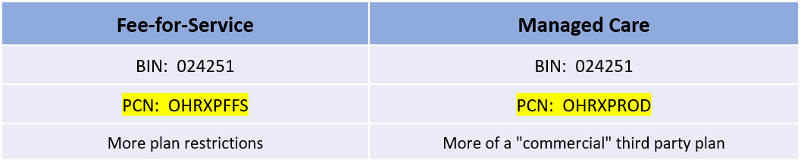

**IMPORTANT** FFS BIN/PCN are changing from the former CHC BIN: 015863 and PCN: OHPOP to BIN: 024251 and PCN: OHRXPFFS – ***Pharmacies may be confused by this. Just explain they need to bill the new BIN/PCN for their FFS Medicaid consumers.***

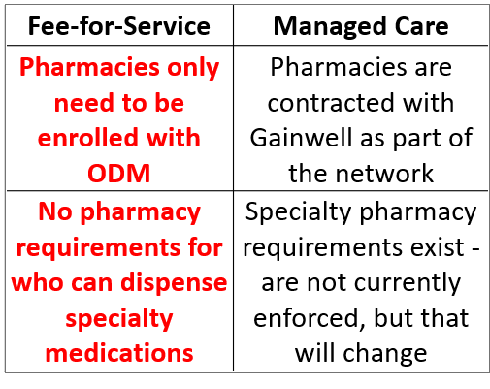

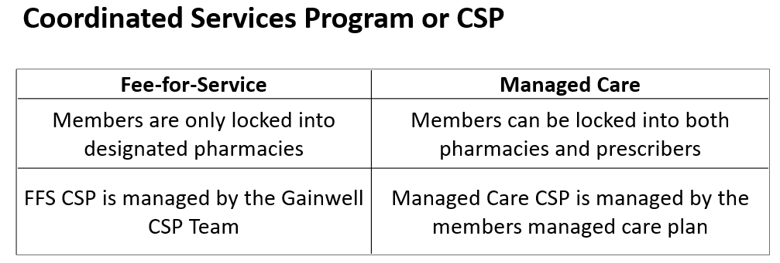

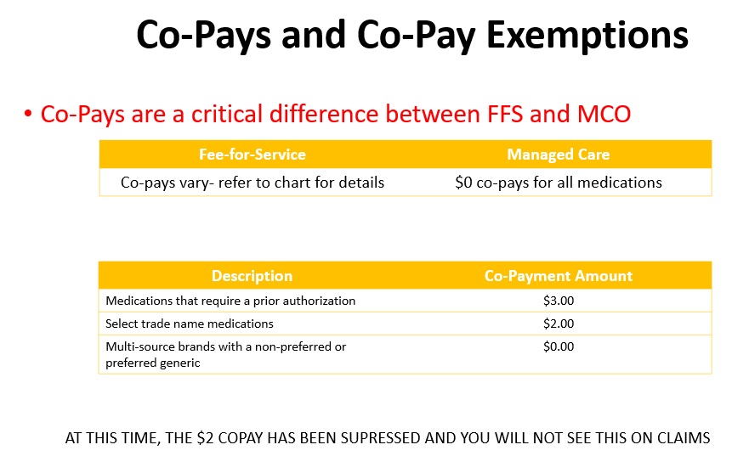

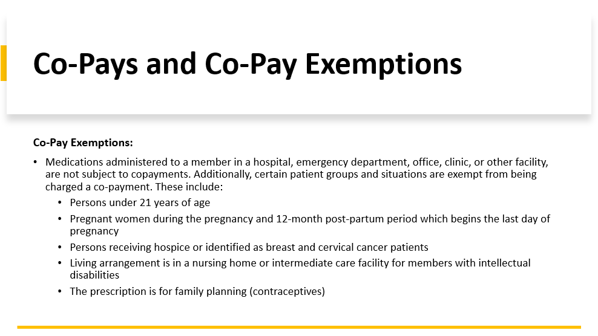

Slide 15

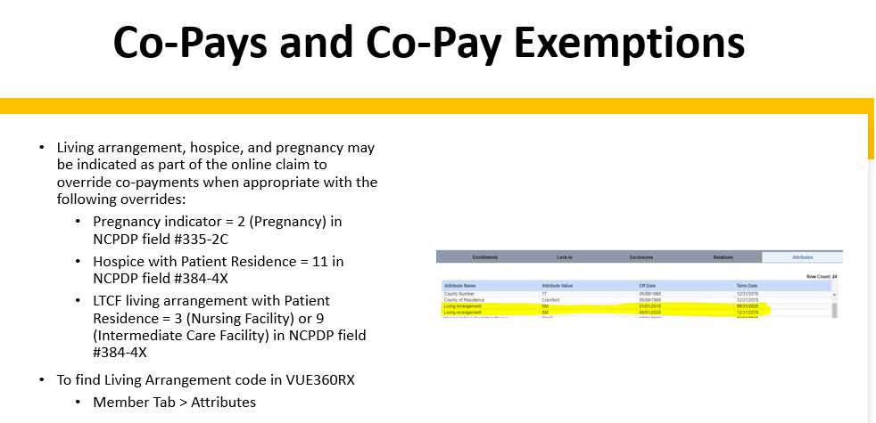

Slide 18

